

Enrichment

Our Intention

The Intent of enrichment at NUAST is to provide extended learning prospects – it gives students the opportunity to study concepts with greater depth, breadth and complexity, while also helping students to pursue their own areas of interest and strengths.

Not only does taking part in an enrichment activity look great on a CV when students apply for higher education, jobs or training schemes, but the transferable skills learnt throughout the activity are significant. The activities can boost self-confidence, develop leadership skills, instil self-motivation and can evidence good time-management. Away from the pressure of passing examinations, enrichment extends students’ education and personal growth. It is all evidence of how a student has a wide array of skills and achievements beyond their subject grades.

Furthermore, enrichment is a fantastic way to increase students’ enjoyment of school life and create an inclusive, community spirit within the school.

Year 7 and 8 Monday Period 6 Enrichment

While the rest of the school are in their usual academic lessons Year 7 and 8 students have a carousel of enrichment activities.

* Year 7 enrichment includes IT and Engineering Projects and extracurricular PE.
* Year 8 enrichment includes Politics, First Aid, Mandarin, Philosophy, Team Building and Go for Growth which is a series of lessons designed for character development, helping them become more resilient, confident and to build a growth mindset.

Optional Enrichment Activities

|  |  |  |  |
| --- | --- | --- | --- |
| Tuesday | Year Group | Wednesday | Year Group |
| School Newspaper | All | LGBTQ+ Support Group | All |
| Knitting Club | All | Homework Club | 7-11 |
| Boardgame/Chess Club | All | NUASTs Most Able (Gifted and Talented) | 7/8 |
| Home Learning Club | 7-11 | Textiles and Sewing | 9/10 |
| Medical Society | 9+ | Sports Leaders | 9/10 |
| ECO Club | 7/8 | Football | 9/10 |
| Guitar Group | 7/8 | Netball | 9/10 |
| The Brilliant Club - Scholars Programme | 9/10 | Duke of Edinburgh | 9/10 |
| Vex Robotics | 9/10 | Study Support | 12/13 |
|  |  | Cooking for University | 12/13 |
|  |  | Mindfulness | 12/13 |
|  |  | Vex Robotics | 12/13 |
|  |  | Green Power | 12/13 |

**The Brilliant Club Scholars Programme**

This programme runs from October 2022 until February 2023. Application only due to limited spaces.

* Students will develop key **university-preparedness skills** including **critical thinking, subject knowledge, written communication**, and **university self-efficacy.**
* Scholars Programme graduates are almost **twice as likely to progress** to highly-selective universities.
* Students will Visit two different Universities, one for the **launch event**, one for your **graduation event**.

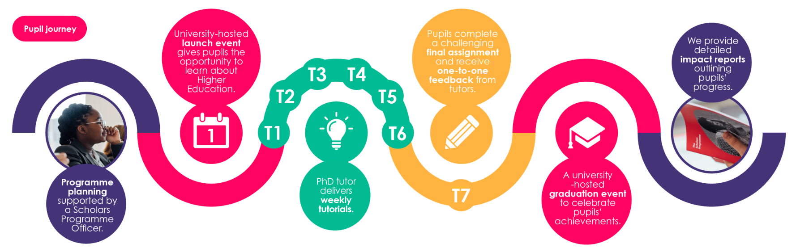

**School Newspaper Club**



**Read all about it!** A newspaper produced by the students, for the students!

* Students who are interested it editing, writing stories, interviewing, creating games and quizzes or even drawing cartoons should join this club!

**Knitting Club**

* A club for complete beginner to expert knitters!
* Students will be taught how to knit, or extend there technical skills if they already can knit.
* Students will be knitting squares, hats and socks for premature babies at the Queens Medical Centre.

**Boardgame & Chess Club**

This club is open to all, chess players can be beginner, intermediate or expert players. But -it’s not just a game – chess improves critical thinking and will help develop the following skills:

1.Problem Solving

2. Abstract Reasoning

3. Calmness Under Pressure

4. Patience

5. Sportsmanship

6. Creative Thinking

7. Pattern Recognition

8. Strategic Thinking

**Home Learning Club**

* Home Learning Club is open to all students and provides a quiet and comfortable place, free from distractions that enables everyone to focus.
* It will allow students to complete work set by teachers to a high standard and gives them access to computers and printing.
* The club will be run by teachers who have the knowledge and experience to help and guide students to the online resources such as encyclopedia.

**ECO Club**

* Eco-Schools programme should be led by students (with a teacher to guide them!)
* Students will use the Seven Step framework as an opportunity to develop their skills and our school’s environmental performance.
* NUAST is hoping to get a Green Flag award (which looks brilliant on applications to colleges or universities!)

**Medical Society**

* The Medical Society has been set up to support students who wish to pursue a career in medicine, veterinary medicine or dentistry. There are guest speaker events, opportunities to discuss the latest in medical science, the NHS, different university courses and how best to prepare for the UKCAT and BMAT (biomedical admissions tests).
* We also endeavor to support and guide students in finding valuable volunteering and work experience, and give them opportunities within the society to develop their team working and leadership skills.

Guitar Group

* An opportunity to learn to play the guitar, and play as a group. Open to beginners to advanced players.
* It’s not just about the guitar, learning an instrument has many other benefits;

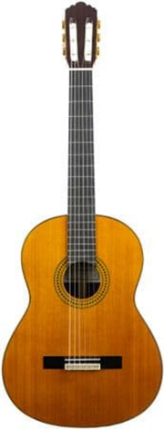1. Improves Memory

2. Enhances Creativity

3. Teaches Discipline

4. Develops Social Skills & Teamwork

5. Improves Performance in Maths!

6. Enhances Coordination

7. Increases Confidence & Self Esteem

8. Sharpens Concentration

9. Music Therapy & Self Expression, good to relieve stress.

10. Playing The Guitar Is Fun!

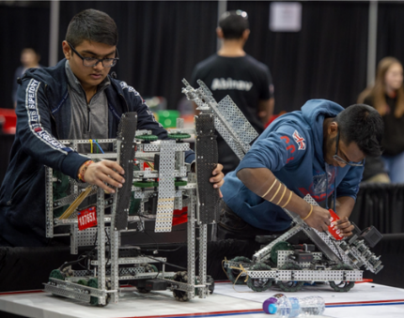Vex Robotics

* Teams of students are tasked with designing and building a robot to play against other teams from around the world in a game-based engineering challenge. Classroom STEM concepts are put to the test on the playing field as students learn lifelong skills in teamwork, leadership, communications, and more. Tournaments are held year-round at the regional, state, and national levels; local champions go on to compete against the best in the world at the VEX Robotics World Championship each April!

**LGBTQ+ Support Group**

* A safe space for LGBTQ+ students and allies to discuss current issues, support one another, explore LGBTQ+ culture (e.g. films), etc.

**Textiles and Sewing**

* Textiles club is an enjoyable, creative way to explore art techniques and create garments and other outcomes.
* Pupils will have the chance to experience a range of fashion and textile techniques including designing, printing, manipulating fabric, felt making and embellishing fabrics.

Most Able Programme Club (invitation only)

* Most Able children are considered to be those who demonstrate a significantly higher level of ability than most pupils of the same age in one or more curriculum areas or in other areas such as leadership or creativity. Most Able students in years 7 and 8 are closely tracked, and are invited to participate in the M.A.P club which aims to personally develop these students, provide academic extension as well as cultural enrichment.
* Activities include: Fundraising, debating, quizzes and spelling competitions just to name a few.

Sports Leaders 

* Students undertaking a qualification in Sports Leadership will learn and demonstrate important life skills such as effective communication and organisation whilst learning to lead basic physical activities to younger people, their peers, older generations and within the community.

Football and Netball

Join the NUAST Football or Netball Clubs and compete against other schools in tournaments throughout the year.

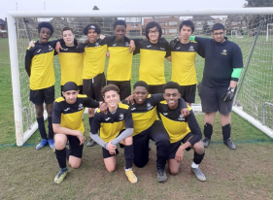

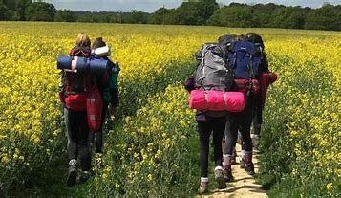Duke of Edinburgh

* DofE empowers young people; to support them as they learn new skills, overcome obstacles, and build confidence and resilience, face the challenges, the frustrations, the triumphs and the laughter. NUAST encourages our students to participate as we believe in youth without limits!

[Parents Information](https://www.dofe.org/do/parents/)

Cooking for University

* This club has been created to help prepare our young people for independent living. Students will learn how to **cook** nutritious food which is fun and easy to make, tastes great, fits a tiny budget and generally can be completed in about 30 minutes!

Mindfulness

This club has student’s mental health and well-being at its heart, we aim to decrease anxiety and stress, encourage forming positive, relaxation-based coping mechanisms to help manage anxious thoughts and feelings and distract from negative thoughts and interrupt a focus on worries about past or future events

Green Power

Greenpower is helping to address the engineering skills gap. The Royal Academy of Engineering estimates that the UK needs 104,000 STEM graduates per year, and 56,000 technicians, between now and 2020.**Greenpower Education Trust is a UK based charity which gets young people enthusiastic about science and engineering by challenging them to design, build and race an electric car.**



****KS5 Study Support



The place for KS5 students to get advice

about good study habits or go to if they

need a quiet space to work.