A-Level Economics Guide

How Economics will be taught:
A level Economics is taught via face-to-face teaching of the subject content; this is by either presentation or lecture. There is plenty of opportunity to explore economic theories and models where students are encouraged to engage in discussion, debate and questioning. All students are given a supporting textbook; these are to support pre and post classroom learning and homework.
Working expectations:
You are expected to put at least as many hours into A level Economics outside of lessons as you would in lessons. A Level Economics requires a real commitment to understand some abstract concepts and this means you will need to be dedicated to developing these thought processes. You will be expected to use study periods to reinforce taught content, as well as develop a deeper understanding of the topics. There is also a focus on reading and writing, therefore you will need to spend time out of lessons practicing these skills as they will ultimately determine your exam success.
What 100% effort in this subject looks like:
- Attending lessons even when not feeling 100%.
- Reinforce taught content using flash cards, mind maps etc. Focus on weak areas.
- Using the supporting text to prepare for upcoming lessons, therefore being more able to contribute to classroom discussion and debate.
- Practicing essay questions from past papers and using subsequent mark schemes to understand indicative content, analysis and evaluation.
- Completing the knowledge booklets issued at the start of the course.
- Reading economics news articles and keeping a record of them.
- Meeting homework deadlines.
Folder Policy:
Your folder should have:
- Course specification and content checklist at the very front.
- 14 subject dividers across both years. The course has two distinct aspects in terms of coverage (Microeconomics and Macroeconomics). Half of Micro and Macro will be taught in Year 12 and same in Year 13.
- After each lesson you should be filing away your notes/worksheets in chronological order. An organised folder keeps an organised mind.
- Marked essays and mock exams to be kept at the back of your folder for reference purposes and to check progress.
- Example essays and other revision materials are also to be kept at the back.

What Marking looks like:
- Ordinary class notes will not be marked, although a folder check will take place every so often
- Some homework will require self-marking and you will be given the answers on a learning platform. These will only be visibly checked.
- Some homework will be revision based, so again, only visibly checked.
- Homework that requires answering 9 mark questions and above will be marked with annotation and a grade.
- Essays questions (25 marks) will be marked with a cover sheet, annotation and development tasks where appropriate
- You will receive a marking coding sheet at the start of the course. This is to highlight annotations used by the teachers in essay writing and prompts for you to consider/reflect.
What Homework looks like:
- Essays (generic and case study).
- Worksheets with multiple choice and short answer questions.
- Group tasks and presentations.
- Research tasks.
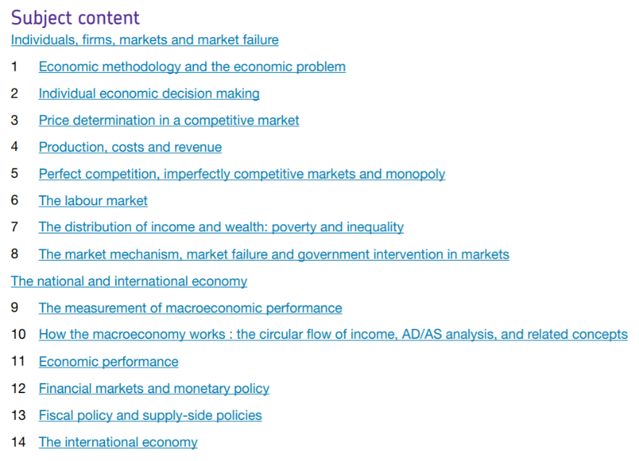
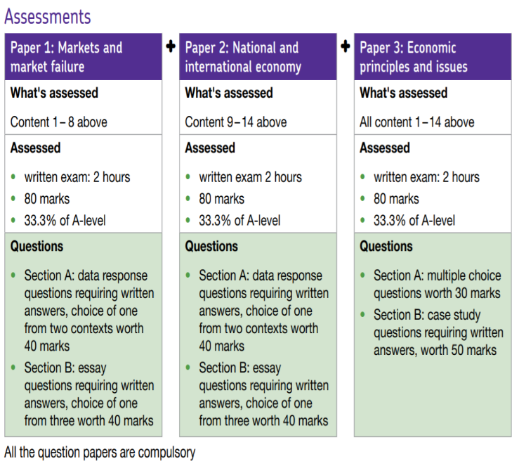
Specification at a glance:

For further information about the specification, please go to:
https://filestore.aqa.org.uk/resources/economics/specifications/AQA-7135-7136-SP-2015.PDF

Summer preparation
In order to get you ready for starting A level Economics it is important that you carry out the following tasks. These will help you bridge some of the gaps between finishing your GCSE’s and starting A levels. This is particularly the case for students who did not studying it at GCSE.
Task 1: Questions
a. Carry out some research and complete the grid.
Key term | Definition | 2018 UK figures | 2019 UK figures
GDP
Inflation
Unemployment
Balance of payments

b. The UK is now leaving the European Union – In your opinion was this the right decision?
Write an essay using the following structure:
- Paragraph 1 – Two arguments that is was the right decision
- Paragraph 2 – Two arguments that it was not the right decision
- Conclusion – Final decision. Think about what is the most important argument is and consider what the success of your decision depends on e.g. striking a good new deal with the EU or with other countries.
Task 2: New articles

Go to either https://www.bbc.co.uk/news/business/economy or https://www.theguardian.com/business/economics and write a summary of 10 different economics related articles. This needs to summarise the issues/problems in the article, how it is affecting the economy or markets. In addition, if applicable, what attempts the government or businesses are doing to manage it.

Task 3: Using exam board materials
Many useful resources for your A level study are provided by the examination board – AQA https://www.aqa.org.uk/subjects/economics/as-and-a-level/economics-7135-7136
Spend some time exploring this website and the specification for information about the course, exam papers, mark schemes and exam reports. Practice is a key part of success at A level, so make sure you are familiar with the types of questions that can be asked.

Task 4: Watch an economics related film
Here are some suggestions:
- Dr. Strangelove(1964)
- Margin Call (2011)
- The Big Short (2015)
- Inside Job (2010)
- The Hudsucker Proxy (1994)
- The Wolf of Wall Street (2013)
- Wall Street (1987)
- A Beautiful Mind (2001)
What was the plot and how was the economy and/or markets affected?

